# Langton’s Ant

Complex behaviour arises out of very simple rules. Here’s a simple set of rules for your “ant” to follow that makes an interesting display.

1. If the ant is on a black square, it turns right 90° and moves forward one unit.  
2. If the ant is on a white square, it turns left 90° and moves forward one unit.  
3. When the ant leaves a square, it inverts the color.

Write a program to simulate the ant using the form’s canvas drawing features. Allow a parameter to make the ant larger or smaller.

If you are attempting this, a good test for correctness is to run the model from an all white world for 386 steps and check it against the example given on <http://mathworld.wolfram.com/LangtonsAnt.html> shown below:

[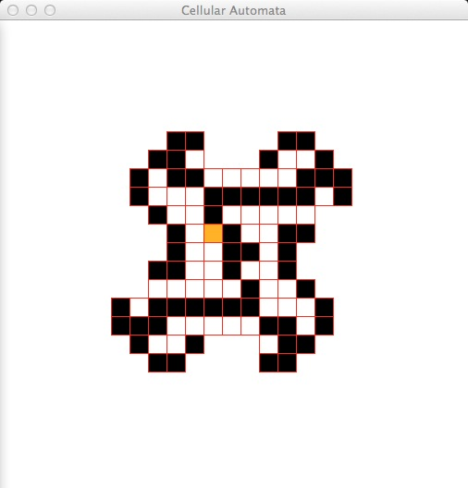](http://compu2learn.co.uk/wp-content/uploads/2013/10/screenshot_712.jpg)

*References*

* [http://en.wikipedia.org/wiki/Langton’s_ant](http://en.wikipedia.org/wiki/Langton's_ant)
* <http://mathworld.wolfram.com/LangtonsAnt.html>